Project: <Enter a project name> | Module 4.2 Assignment-Test Plan
Course: <Enter the course number and name> | CSD380-O301
Description: <Enter a description> | Creating a test plan for to do site
Date: <Enter a date (yyyy/mm/dd)> | Due: 9/7/2025
To complete the test case plan, fill out the information for Project, Course, Description and Date in the header below.
.
TABLE OF CONTENTS
Edit a todo task item 3
Prevent users from submitting a blank edit form 6
Provide users with a view for mobile devices 8
Delete a todo task item 13
Prevent users from submitting a task form with without entering a todo item 16

For each test, the developer should: provide a test description, a test objective, the developer name and date tested. For each step, fill out the actions to be taken and describe the expected results, and indicate yes or no for each step depending upon the result. The peer tester should provide their name, date tested, indicate yes or no for each step depending upon the result, and a screenshot (thumbnail) of the result.

Test 1 | Edit a todo task item
 | Test Objective: After adding an item to the list, ensure user can edit the item | Developer: DeJanae Faison  Date tested: 9/4/2025 | Peer tester: Jess Monnier  Date tested: 2025/09/06
Step | Action | Expected results: | Developer pass/fail | Tester pass/fail  + Screenshot
1 | Visit site | Page loads with no errors | Yes | Yes  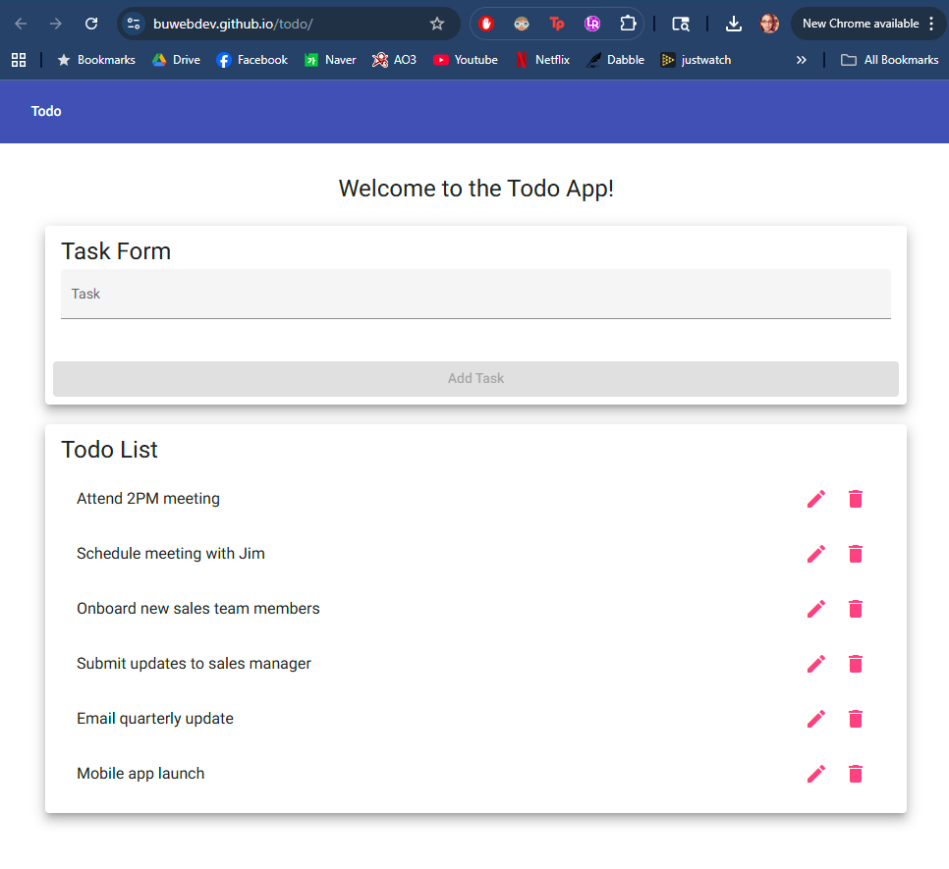
2 | Type in task and add task | Task appended to the list | Yes | Yes  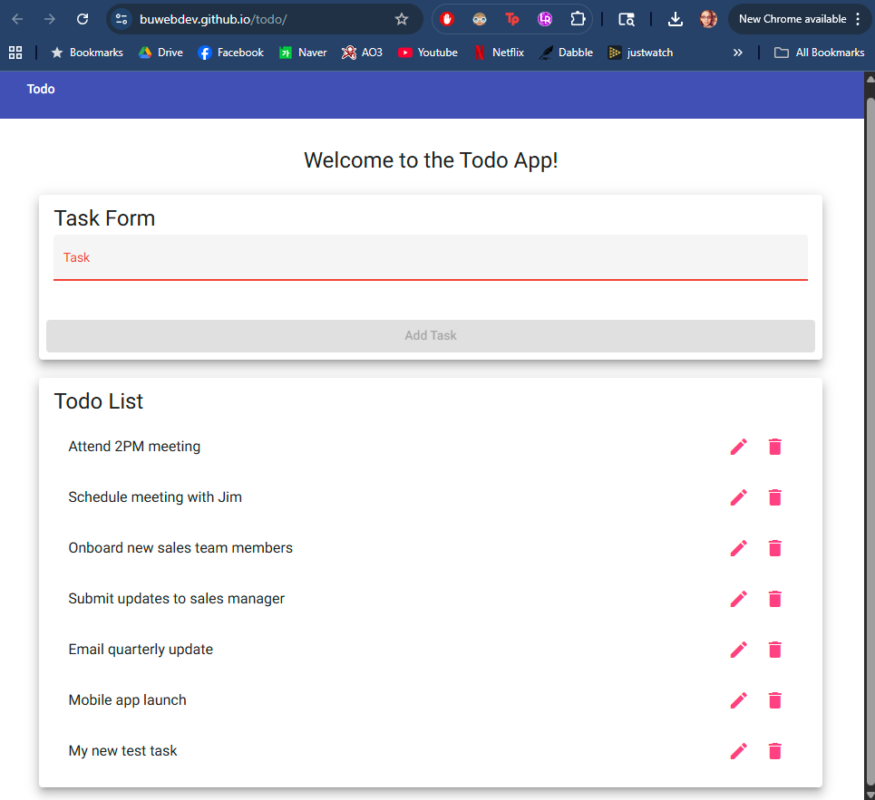
3 | To newly added task, select the pencil icon | Edit window to appear/ ability to change the task | Yes | Yes  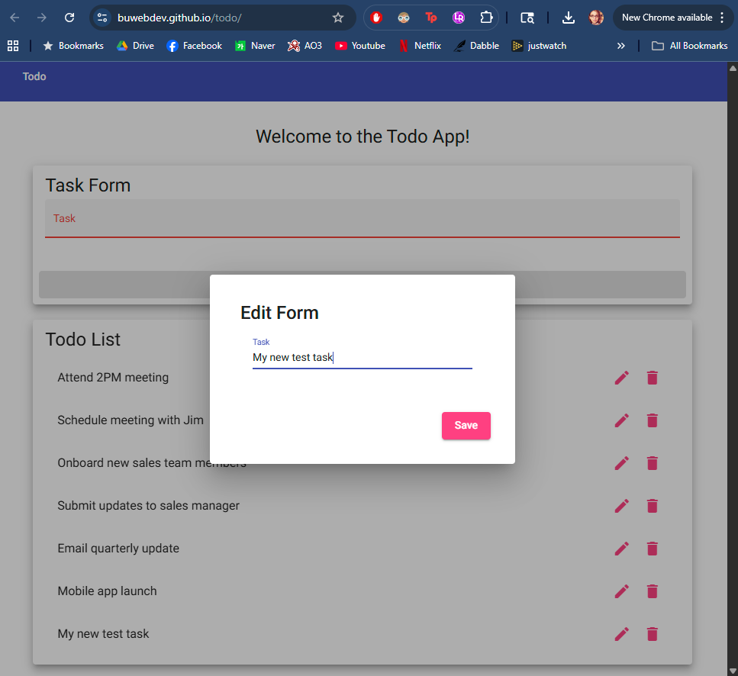
4 | Type in edit and save | After selecting save the window should disappear | Yes | Yes  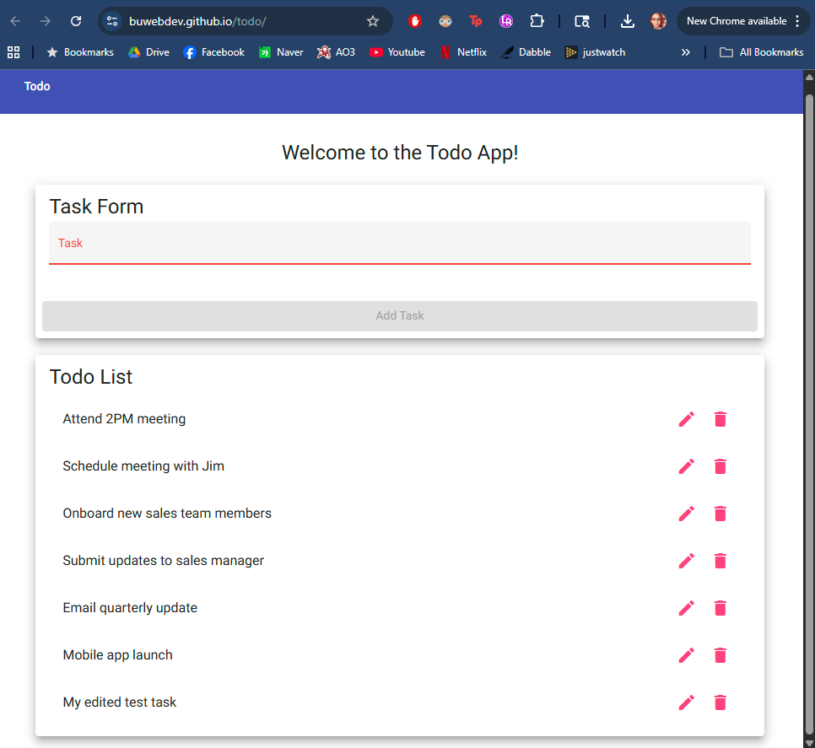
5 | Ensure changes reflect in list | Custom task reflects the changes that were made now in list | Yes | Yes (see above screenshot, it’s the same)
Comments | The edit task icon is responsive, quickly popping up an in-page dialog to edit the task text. Clicking Save refreshes the page with the new task text displayed in place of the old. However, the task text can be deleted, allowing a blank task to be saved. Additionally it might be nice to have a cancel or close button.
Test 2 | Prevent users from submitting a blank edit form
 | Test Objective: After selecting to edit a task, user should not be able to leave the task area empty and hit submit | Developer: DeJanae Faison  Date tested: 9/5/2025 | Peer tester: Jess Monnier  Date tested: 2025/09/06
Step | Action | Expected results: | Developer pass/fail | Tester pass/fail
1 | Visit site | Page loads with no errors | Yes | Yes  
2 | Select pencil icon on preset task | Edit window appears | Yes | Yes  
3 | Delete task from text box | Empty textbox | Yes | Yes  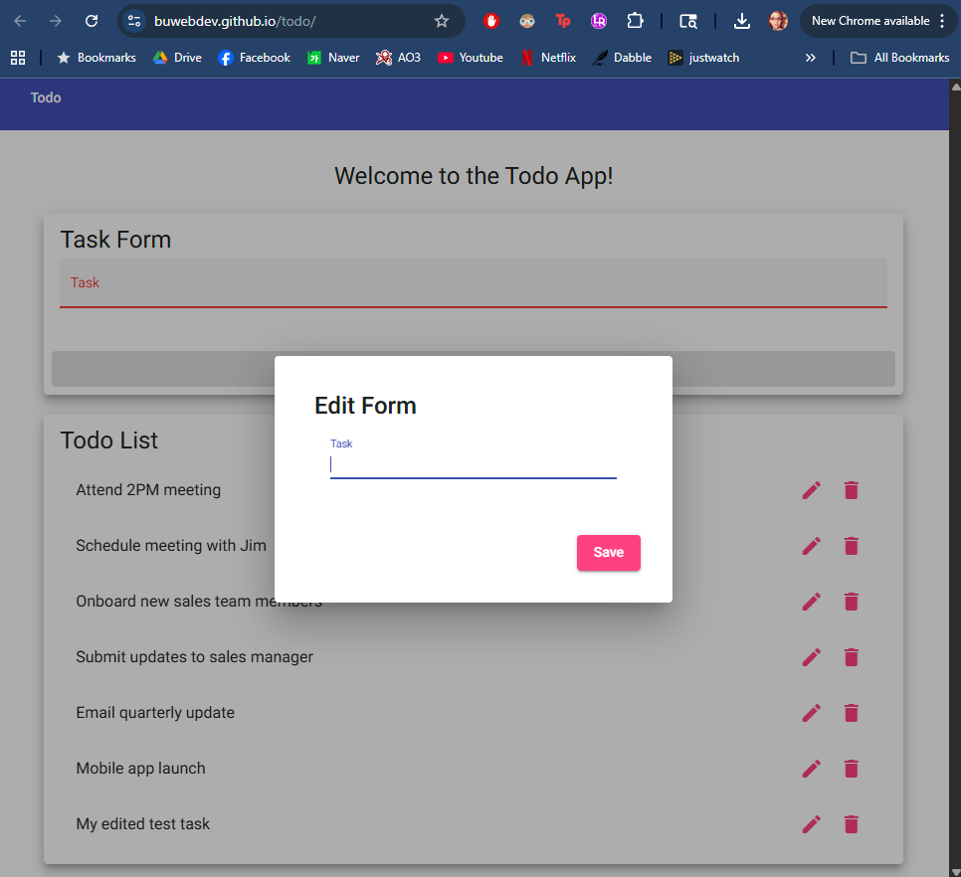
4 | If empty, do not allow user to save | Save button grayed not allowing user to save | No | No (see above screenshot, it’s the same)
5 | If it has text, allow user to save | After selecting save, the edit window will disappear and the to do list will be updated | Yes | Yes  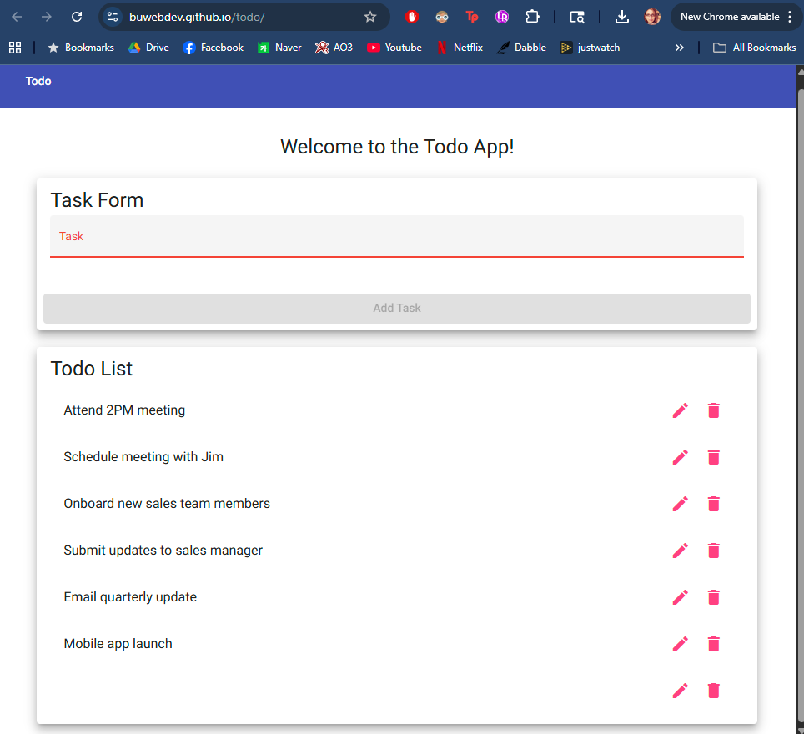
Comments | The Task text field appears to have a minimum character requirement of some kind and the Add Task button is disabled until that minimum requirement is met. However, the requirement can be met by white space, which is not ideal.

Test 3 | Provide users with a view for mobile devices
 | Test Objective: Recreate the same basic functions on mobile device | Developer: DeJanae Faison  Date tested: 9/5/2025 | Peer tester: Jess Monnier  Date tested: 2025/09/06
Step | Action | Expected results: | Developer pass/fail | Tester pass/fail
1 | On mobile Device, visit URL | Page loads with no errors or overlapping content | Yes | Yes  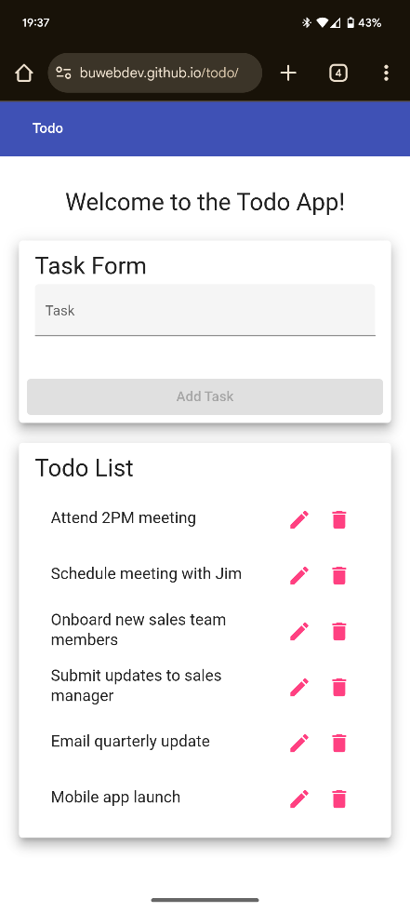
2 | Select text box, type in task, select add task | Keyboard to appear, after typing task and submitting, task should append to end of list | Yes | Yes  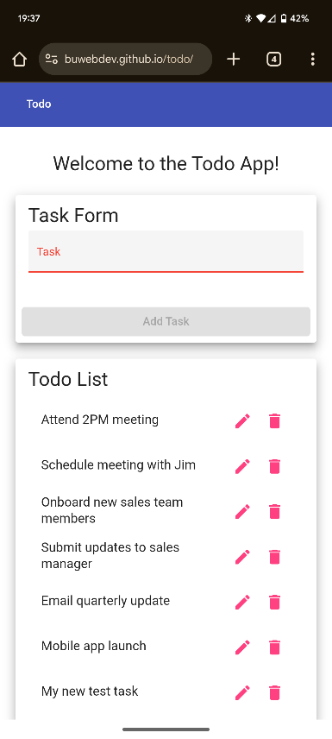
3 | Select the pencil on a random task, edit the text and select submit | Edited task viewed in list | Yes | Yes  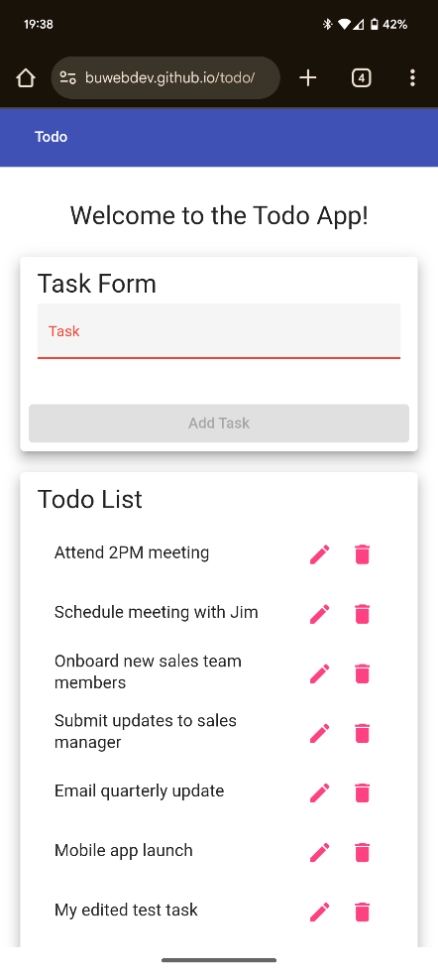
4 | Select the trash icon on a random task | Deletes the task | Yes | Yes  
5 | Delete all the tasks on the list | When the list no longer over stretches the view, screen should no longer be scrollable | Yes | Yes  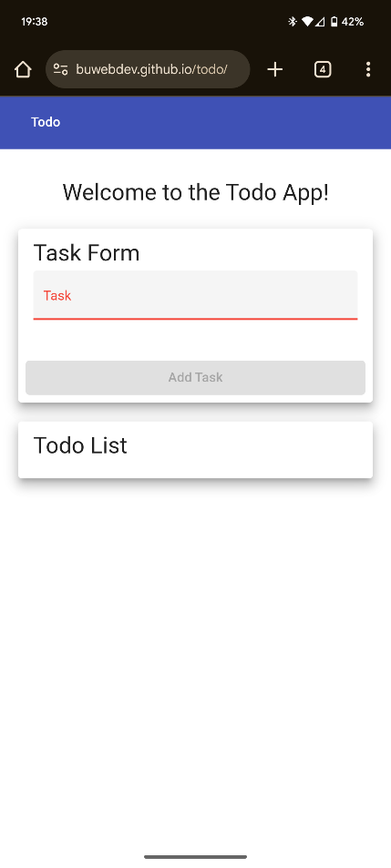
Comments | The mobile view of the todo website is neat and responsive. This appears to be a site where perhaps mobile view was prioritized, since it has a minimalistic look in a computer browser and doesn’t really look much different on the phone, but still works well.

Test 4 | Delete a todo task item
 | Test Objective: Properly discard task item no matter the placement | Developer: DeJanae Faison  Date tested: 9/15/2025 | Peer tester: Jess Monnier  Date tested: 2025/09/06
Step | Action | Expected results: | Developer pass/fail | Tester pass/fail
1 | Visit site | Page loads with no errors | Yes | Yes  
2 | Select the trash icon on the last task | Last task should disappear and shrink the list | Yes | Yes  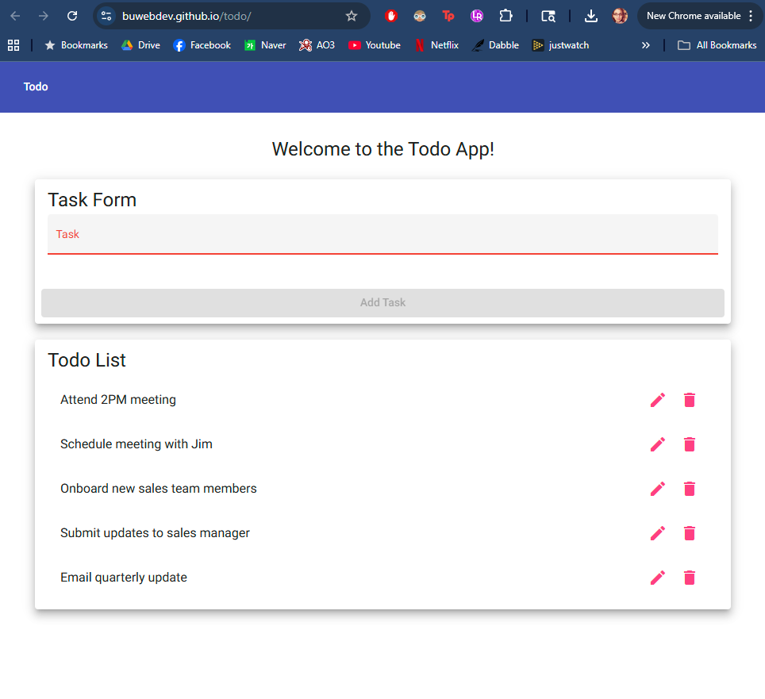
3 | Select the trash icon on a task in the middle of the list (ex. Onboard new sales team members) | Task should disappear, task bellow deleted task should move upward / no gaps | Yes | Yes  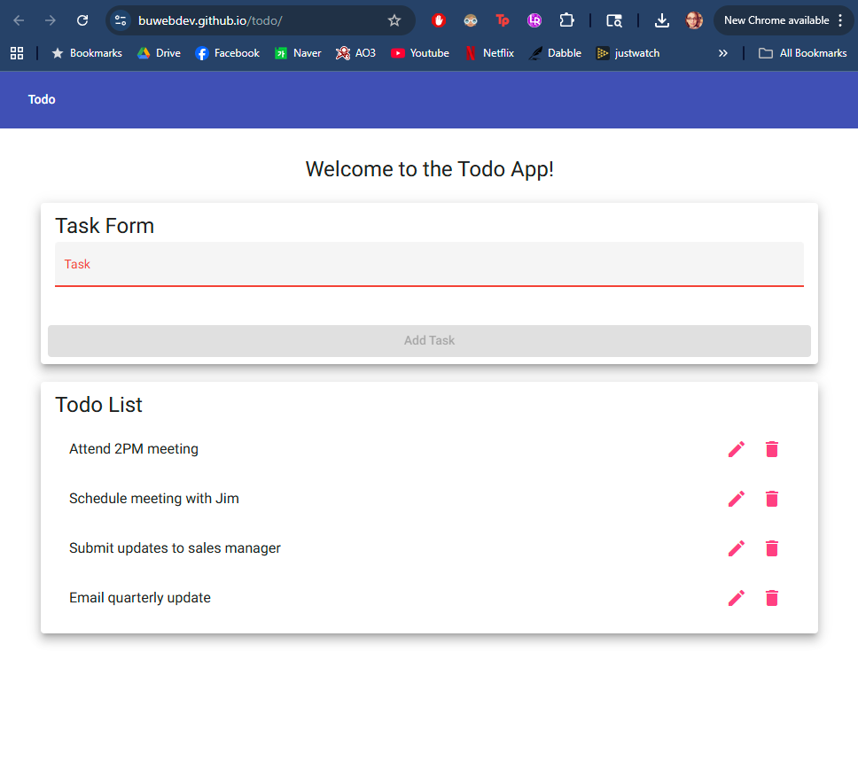
4 | Delete the first task on the list | Task should disappear and the entire list should move up | Yes | Yes  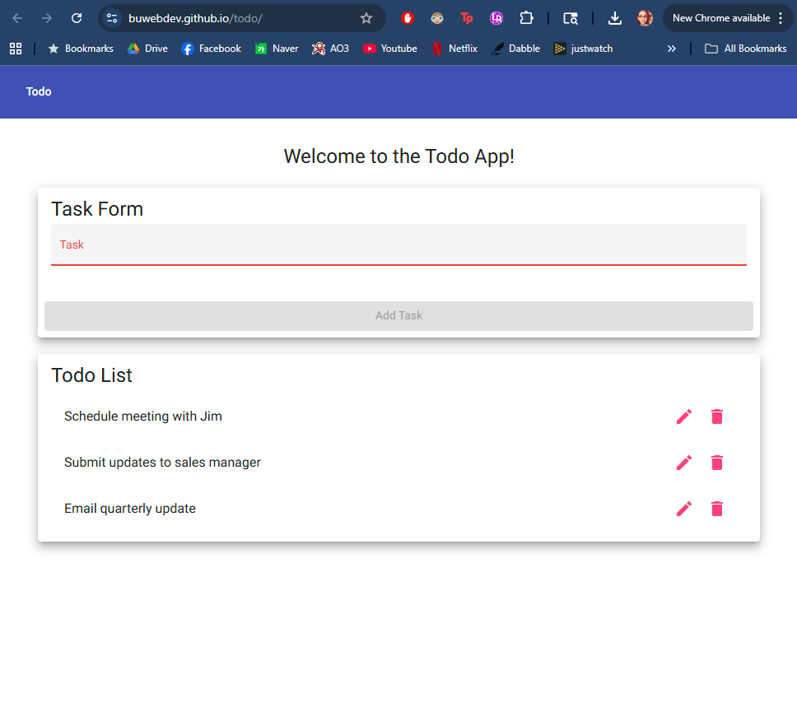
5 | Delete every task on the list | Nothing should be on the task list | Yes | Yes  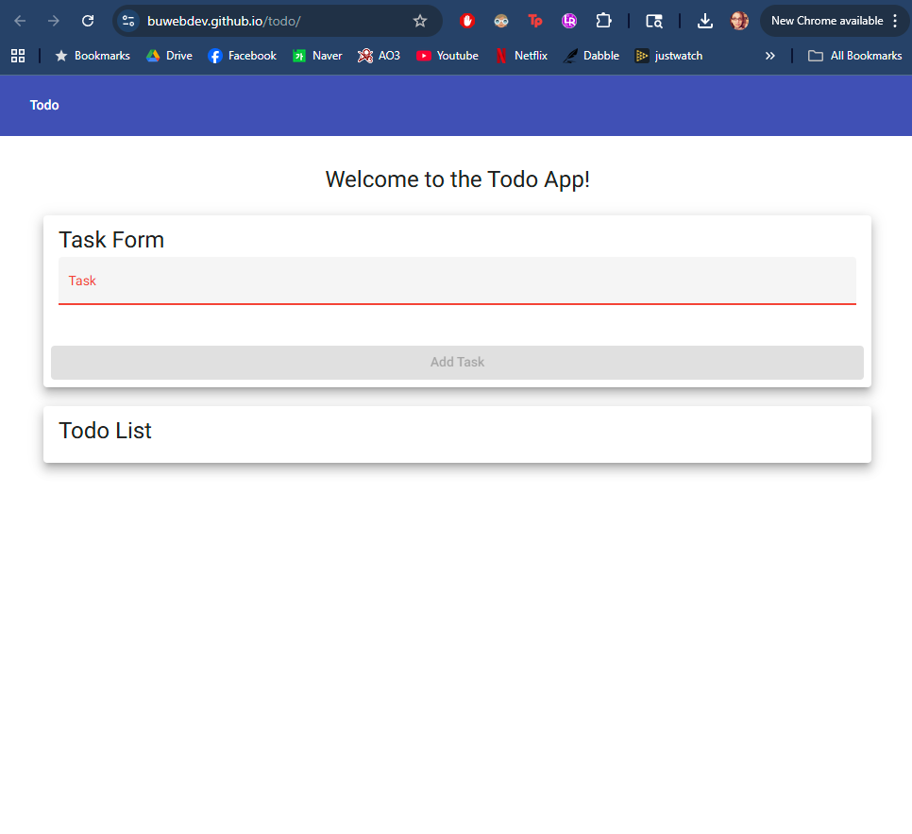
Comments | The delete icons are responsive, quickly reloading the page with that task removed. It might be prudent to add a confirmation dialog in case the icon is clicked accidentally.

Test 5 | Prevent users from submitting a task form with without entering a todo item
 | Test Objective: If text field is empty, user can not submit blank task | Developer: DeJanae Faison  Date tested: 9/5/2025 | Peer tester: Jess Monnier  Date tested: 2025/09/06
Step | Action | Expected results: | Developer pass/fail | Tester pass/fail
1 | Visit Site | Ensure it loads with no errors | Yes | Yes  
2 | Select task field but with nothing in the field select add task | User unable to add task | Yes | Yes (looks the same as above)
3 | In task field, press your ‘space’ button several times, select add task | Though ‘blank’ user should still not be able to add blank task | No | No  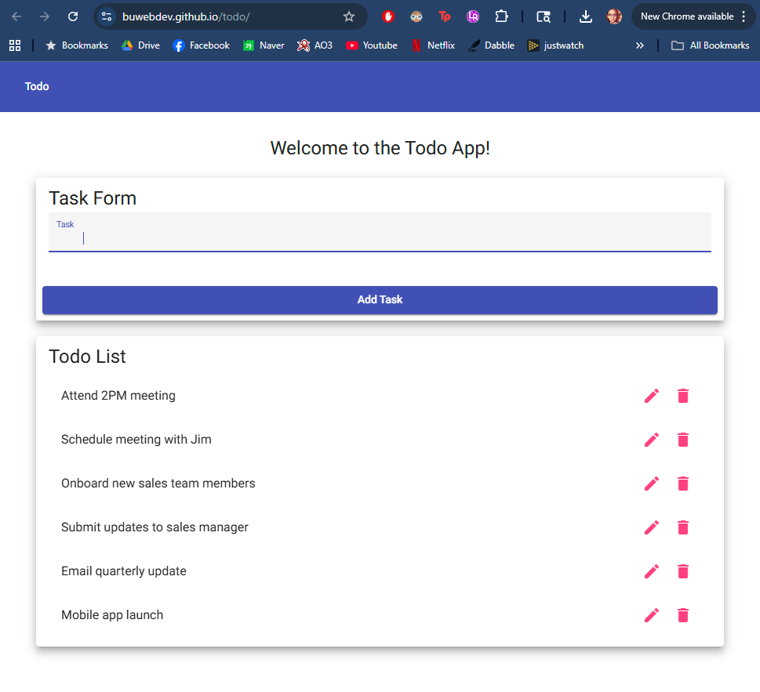  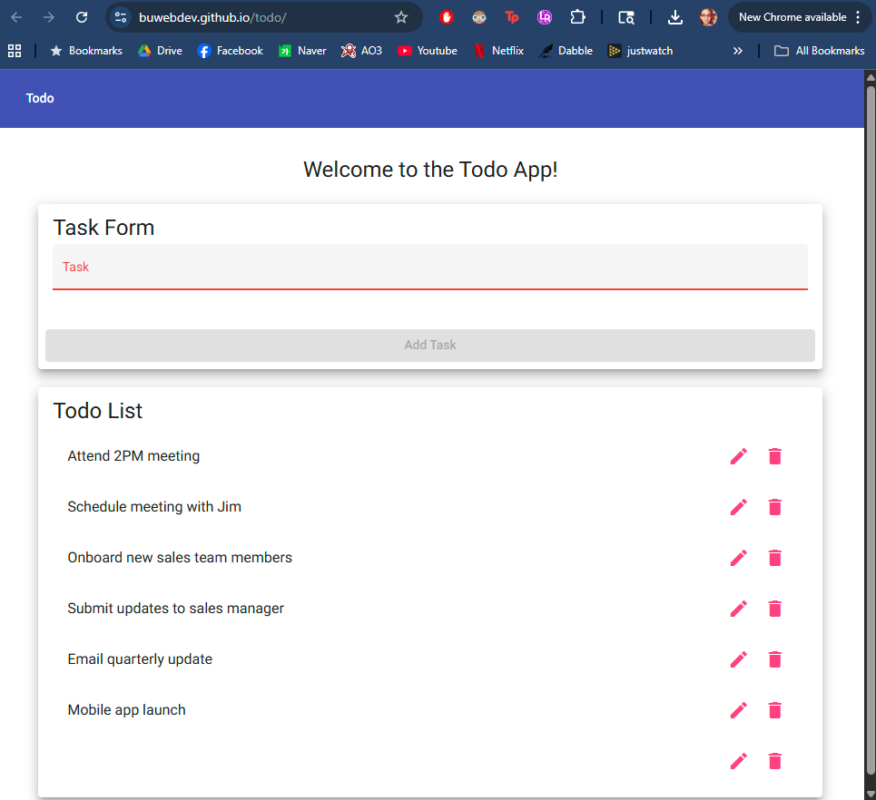
Comments | The Task text field appears to have a minimum character requirement of some kind and the Add Task button is disabled until that minimum requirement is met. However, the requirement can be met by white space, which is not ideal. This means that a blank task can still be submitted, in a way.

